**ADAPTIVE AND SELF-LEARNING SMART STREET LIGHTING AUTOMATION**

THE VIGYAANEERS

Paras Lehana

Ayushmaan Bansal

Yash Garg

Abhinav Bansal



**July – 2018**

**TABLE OF CONTENTS**

DECLARATION III

CERTIFICATE IV

ACKNOWLEDGEMENT V

SUMMARY VI

LIST OF FIGURES VII

LIST OF TABLES VIII

LIST OF SYMBOLS & ACRONYMS IX

CHAPTER 1: INTRODUCTION 1

1.1 General Introduction 1

1.2 Problem Statement 2

1.3 Empirical Study 3

1.4 Approach to problem 6

1.5 Significance of problem 6

1.6 Comparison of other existing approaches 7

CHAPTER 2: LITERATURE SURVEY 8

2.1 Summary of papers studied 8

2.2 Integrated summary of the literature studied 21

CHAPTER 3: ANALYSIS, DESIGN AND MODELING 23

3.1 Overall Description 23

3.2 Functional Requirements 25

3.3 Non-Functional Requirements 25

3.4 Logical Database Requirements 28

3.5 Design Documentation 27

3.5.1 Use Case 27

3.5.2 Flow Diagram 28

3.5.3 Class Diagram 29

3.5.4 Activity Diagram 30

CHAPTER 4: IMPLEMENTATION DETAILS AND ISSUES 31

4.1 Implementation Details 31

4.2 Risk Analysis 37

4.3 Mitigation Approaches 37

4.4 Algorithms 38

CHAPTER 5: TESTING 39

5.1 Testing Plan 39

5.2 Component decomposition 40

5.3 Error and Exception Handling 40

5.4 Test Cases 41

5.5 Limitations of the solution 42

CHAPTER 6: FINDINGS & CONCLUSION 43

6.1 Findings 43

6.2 Conclusion 43

6.3 Future Work 44

REFERENCES 45

# SUMMARY

Adaptive Smart Street Lightning is a module to automate existing street lights infrastructure using deployment of cost-efficient ESP8266 WiFi chipsets. The module optimizes group's net intensity (thereby energy costs) using self-learning over attributes like area light intensity (using LDR), weather conditions (like cloudiness, temperature, visibility), geolocation (using Google Maps API), time of the day and Master Control. A group of Street Lights (belonging to a colony or area) is a (sub)network and thus bears an IP address that can be controlled by the administrators using local internet/Wi-Fi (the android interface that allows this is the Master Control). Moreover, the street network is not hard-coded into the app but is managed via cloud server (Firebase) allowing real-time management. The module will thus help connect a network of street lights arrive at a collective optimized intensity to further reduce net energy consumptions as well as collect environmental parameters that could be used to generate datasets for statistical analysis and predictions using Fuzzy Inference System and/or Machine Learning Algorithms. The approach can be extended to whole city or state department and can additionally help rectify local errors such as a non-working street light or those depicted by the collected data. While administrators would have advanced tools to control and manage the network through mobile or web authorized interfaces, citizens would be able to view their local and global street lights cluster and can have further access to corresponding open data.

__________________ __________________ __________________

Signature of Student Signature of Student Signature of Student  
Paras Lehana Pradeep Asthana Abhinav Bansal

Date: Date: Date:

__________________

Signature of Supervisor

Santosh Kumar Verma

Date:

# LIST OF FIGURES

**Figure Title**   **Page**

1.1 Public Lighting Demand 3

3.1 Circuit Diagram of Light Sensing Module 24

3.2 Firebase Application 26

3.3 Use Case Diagram 27

3.4 Flow Diagram 28

3.5 Class Diagram 29

3.6 Activity Diagram 30

4.1 Establishing communication between ESP8266 and port 31

4.2 Uploading of LUA script in ESPlorer 32

4.3 Hardware Module for Remote Control Operation 33

4.4 SMART STREET App 34

4.5 Firebase Authentication and Database 35

4.6 Controlling the illumination system from remote PDA 36

4.7 ModuleLDR Algorithm 38

# LIST OF TABLES

**Table Title**   **Page**

1.1 State-wise street lighting data 4

1.2 Recent Public lighting energy use and growth rates 5

1.3 Public Lighting Base case scenario for 2020 by technology type 5

1.4 Comparison of other existing approaches 7

2.1 Comparison of different approaches to IoT based Street Lighting System 20

4.1 Risk Analysis Table 37

4.2 Mitigation Table 38

5.1 Testing Plan 39

5.2 Component decomposition 40

5.3 Error and Exception Handling 40

5.4 Test Cases 41

# LIST OF SYMBOLS & ACRONYMS

1. **RISC:** Reduced Instructions Set Computer
2. **LED:** Light Emitting Diode
3. **PDA:** Personal Digital Assistant
4. **ESP:** Electronic Stability Program
5. **P2P:** Purchase to Pay
6. **MIC:** Message Integrity Code Computing
7. **LDR:** Light Dependent Resistor
8. **ULN:** Upper Limit of Normal
9. **LCD:** Liquid Crystal Display
10. **AC:** Alternating Current
11. **GSM:** Global System for Mobile Communication

# CHAPTER 1: INTRODUCTION

## **1.1 General Introduction**

Light and energy saving is a standout amongst the most critical step to be taken for present scenario. Automatic systems including IoT (Internet of Things) plays a significant role to achieve the solution for the issue. ESP8266, a Wi-Fi processor, is utilized as a part of the venture that is reliable as well as economical. It associates with the LUA interface effortlessly and is best for embedded system designing. LDR and related sensors are utilized to detect the lights. The thing that should be dealt with is the electrical segments that are required to make a solid circuit and the outline of the circuit through Eagle device, the right measure of voltage provided to the circuit, revise patching of parts and appropriate associations with be finished. Authorized users communicate through the Android application SmartStreet to control or monitor, depending on user level, the street lights situated in different locations in an area. Thus, the proposed system is easy, reliable, economical and efficient to implement and hence saving energy and optimizing light intensity.

Controlled energy and light utilization is extremely pivotal to spare the exhausting natural resources with the goal that future ages could make utilization of the facilities. IoT is an emerging trend these days and the vast majority of the frameworks depend on it. Gadgets and systems can be remotely accessed with the assistance of Wi-Fi. IoT based energy meter reading and IoT based light frameworks are examples of this approach and are a creative use of real-time embedded systems. LDR sensors and Wi-Fi signals are used that sends an interrupt signals to the microcontroller for each flash of LED [15]. Programmed light system is utilized as a part of deciding when to enact road lights at various times of the year. The automatic system is also helpful for security purposes or in emergency at home, offices, and organizations by activating the appropriate sensor, programming and alerting respective authorized users [1,8].

The focus of this research is to design an embedded system for automatic controlling the light system, optimizing energy usage and learning light patterns over areal and weather patterns. Hardware circuit and programmable interface is important for the realization of the system. Low cost, economical and efficient system has to be used so that it can be applied in any organization, thus, saving power. Various input sensors have to be properly utilized that can convert the analog signals to digital ones. All the information is passed to microcontroller that can save the information in memory and produce analog output that users can see in LCD displays. The illumination system developed is reliable, efficient and economical.

## **1.2 Problem Statement**

The primary theme of discussion in this day and age is on the most proficient method to decrease the energy utilization and greenhouse gases emission on everyday premise. As per a report of 2014 there are 280 million street lights globally. Each street light on an average expends around 300 to 1000 kWh of energy every year. But since there is no monitoring of these street lights, they sometime operate even when they are not required to operate like in daylights or even when light is sufficient to be seen by individuals and this extra consumption of energy leads to around ₹1700 to ₹8400 ($25 to $125) wastage of money on each street light annually along the globe. Also, each street is responsible to produce about 300 to 1500 Kg of CO2 each year which ultimately is released to our atmosphere. More major issues happen when they are not working legitimately at a given time. As there are a great many of them, finding the flawed one is time-consuming and detecting the faulty one as soon as the fault occurs is next to impossible. Also because of absence of a centralized control system it becomes unsafe in many practical situations which ultimately leads to road accident as on an average it takes about 20 hours to find and repair a faulty light in ideal case which using this system will reduce to an average of 30 min as it will be already known as of which and where the fault has occurred. Also, the data obtained from systems like the proposed can be considered to be applied for data mining and machine learning which would ultimately lead to a boom in the use of such technology. Also, street lights currently do not employ the weather conditions to take decision about the lightning of street lights which is one of the major factor as time at which daylight vanishes depends on the weather condition as well as the timezone There needs to be a centralized system connected to internet or local network through which authorities can control lightning of the whole area remotely as well as with the assistance of which users could monitor them anywhere and anytime.

The module at its very basic assists to toggle the lights or control its intensity based on various parameters like intensity, area/timezone, time, and orientation of the cluster of poles of light. The principle aim of the project is to design interfaces using LUA programming environment and to establish communication of server with sensory ports and other sub-units. Each controller will have sensors like LDR, current, voltage, temperature, real time clock to detect the suitable light pattern and take action as desired by the device that time. Small, simple and low-cost microcontrollers are used that provides greater capability, efficiency and accuracy in dealing with the system. Thus, the major objective of the proposed research work is to design embedded system with hardware and software application to generate automatic light system that in turn can save light and power in any university, institution, organization or large establishments effectively and efficiently.

## **1.3 Empirical Study**

A plenty of surveys have been done for street lighting data and energy usage. The author in [4] also estimated the energy savings by using LDR for light automation. It was assumed that for a minimum of 2 hours a day, the lights were kept on uselessly. The lights were of Sodium Vapour which are 400W each. By automating only 50 street lights, author estimated a saving of 40 kWh per day and 14,400 kWh per year. The EESL Toolkit for Street Light Energy Efficiency [10] has projected the energy consumption in Indian public lighting sector for 2021-22 given the available data for previous years as per the 18th Electric Power Survey of CEA.

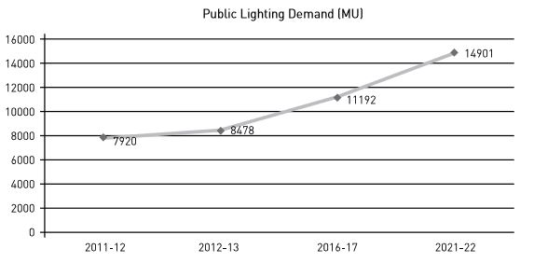

**Fig. 1.1:** Public Lighting Demand

The toolkit has also compiled state-wise data for no. of lights and related information which can be used for urban and rural implementation according to the area-wise data. The data is summarized in Table 1.1.

Energy Savings Potential for Street Lighting in India [11] estimates that the average growth rate per year in energy consumption over last 10 years is around 7.0%. This is summarized in Table 1.2 whereas the energy usage for 2010 and 2020 by technology type is provided in Table 1.3.

The discussed report by EESL [9] estimates that there are more than 3 million street lights in India. Even using the basic implementation of LDR as depicted in [4] gives an annual savings of around 900 GWh which attributes 10% more savings as per the DELP project. On world level, it is worth more than 80 TWh of energy savings.

**Table 1.1:** State-wise street lighting data

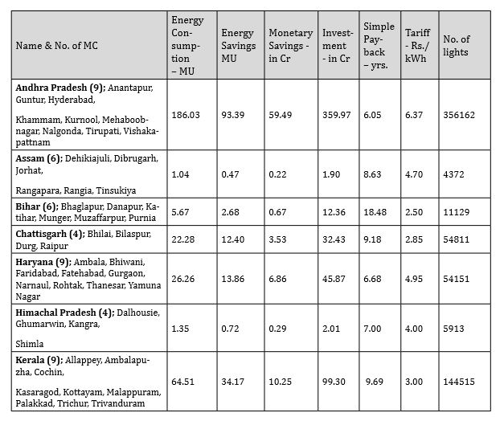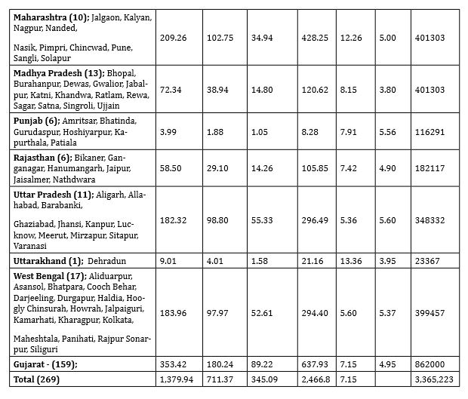

**Source:** EESL Toolkit for Street Light Energy Efficiency

**Table 1.2:** Recent Public lighting energy use and growth rates

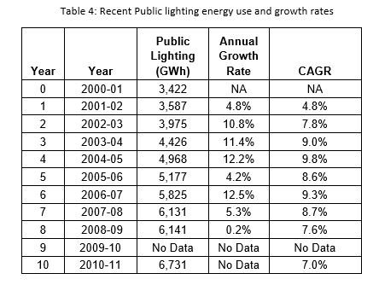

**Source:** Energy Savings Potential for Street Lighting in India

**Table 1.3:** Public Lighting Base case scenario for 2020 by technology type

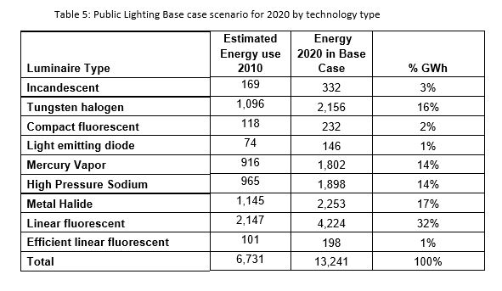

**Source:** Energy Savings Potential for Street Lighting in India

## **1.4 Approach to problem**

For the initial phase, the phototransistor senses the amount of light over it and adjusts the intensity of the street light or a cluster of street lights. In second phase, the master control implements supervised learning and analyzes the error between actual output and expected output. For example, LDR is simply a sensor that it like all other electronic devices error-prone. Suppose a case where the time is 9:00 PM but headlight of a car imposed on the sensor (maybe accidentally) can make the sensor not to trigger light ON. Similarly, a bird sitting on the sensor even in a condition of ample sunlight can cause the sensor to trigger light ON. Machine learning can make the module learn about parameters like sensor reading, time, temperature, weather and other devices outputs in the same cluster (group of lights like in a colony). The third phase consists of the learned dataset that would now control lightning according to these parameters. The module will then continue learning from its experience and feedback.

## **1.5 Significance of problem**

Internet of Things (IoT) is in this day and age a trending technology around the world. Government, academia, and industry are associated with varied aspects of research execution and business with IoT. IoT cuts over various application fields including space, healthcare, agriculture, construction, manufacturing, water and mining, which are presently progressing their legacy framework to support IoT. Today it is conceivable to imagine unavoidable network, stockpiling, and calculation, which, thusly, offers ascend to building distinctive IoT solutions. IoT-based applications such as innovative shopping system, infrastructure management in both urban and rural regions, remote health monitoring and emergency alert systems, and transportation systems, are gradually depending on IoT based systems. Embedded systems with the server hardware and programmable LUA interface plays a pivotal role in developing automatic appliances and controlling them by providing ease to the complexity of human life. The competitive world in which we are surviving requires paying most of the attention to the natural resources like coal, water, natural gas and light energy. Careless attitude can bring harm to the society, thus leaving future generation as sufferers or devoid of basic amenities. Saving power and money is important and therefore switching OFF the lights when not required is crucial. In order to reduce manual involvement and to provide flexibility and convenience to the humans, automatic system is developed.

## **1.6 Comparison of other existing approaches**

**Table 1.4:** Comparison of other existing approaches

|  |  |  |
| --- | --- | --- |
| **Reference** | **Our Approach** | **Existing Approach** |
| [2] | LDR used to measure intensity; MSP430 microcontroller is used. Output is binary i.e. ON or OFF. | In addition to LDR, weather data is also fetched. ESP8266 enables Wi-Fi connectivity. Output is intensity percentage for the cluster. |
| [3] | Discussed how energy can be saved using IoT based approaches. | Implemented the light intensity and time based automatic street lighting control system and estimated the energy saved. |
| [4] | LDR is used to measure intensity and then energy saved is calculated. | In addition to LDR, cloud database, weather API, Master Control and learning module is also implemented. |
| [14] | LDR is used to detect resistance while the output is binary. | The output is a continuous value depicting required counter intensity that is function of the learning algorithm. |
| [17] | ESP8266 is used to collect LDR values as well as parameters like temperature and humidity. | In addition to fetching related parameters, this data is also sent to Cloud Database. Data mining could be used over this data set then. |
| [33] | Raspberry Pi is used as the interface to connect LDR to the cluster. GSM is used for remote communication. | ESP8266 is used as automatic controller with the help of Lua programming interface. It is more cost efficient. Wi-Fi is used for remote connectivity. |

# CHAPTER 2: LITERATURE SURVEY

## **2.1 Summary of papers studied**

***Paper 1 (Year 2017)***

**TITLE: IoT based smart and adaptive lighting in street lights**

**AUTHORS:** B. Abhinaya, S. Gurupriya, M. Pooja

**WEB LINK:** *http://ieeexplore.ieee.org/document/7972267/*

**SUMMARY:** Authors in [2] have proposed a similar IoT based smart and adaptive lightning system though they don’t talk about any scope of data mining on the sensor data collected. In the paper, authors proposed a system used for smart and weather adaptive lighting in street lights. Nowadays, major expenses in the transportation and municipal management involves that due to the street lights. If revamped to proposed Smart Street Light model, it is estimated to reduce the consumption by 50-60%. The phototransistor in the model whenever detects the sunlight or any form of high intensity light, the connected street light is turned off automatically to save energy and money. Additionally, the system analysts and administrators can see the street light status on their connected control machines through the local network or also the internet via remote access. Street light controller is setup on the poles of street light along with the microcontroller, and some sensors used to detect the lights and send information to microcontroller to take appropriate action to it. In Controller, camera is also installed to capture the footages in real time and stored it in a server database and also an emergency button is present on pole during the emergency situation like theft, attack, accidents etc. and on pressing the button, current video footage with an alert is sent to nearest police station. Author proposed a problem in current existing street light system, like manual system is used to ON/OFF the lights, more energy consumption and also more manpower for the periodic check. The proposed solution implements Automated Street control system that should be used to reduce energy consumption, reduce light pollution and man power is completely eliminated. In this project, MSP430 mixed microcontroller is used, which is built for being economical as well as consume less power. LDR (Light Detection Resistor) device is used whose resistivity factor is dependent on the electromagnetic radiation which makes them similar to human eyes, LDR works on photo conductivity phenomenon in which its conductivity is reduced by absorbing the lights. Some more components like Panic Button during emergency situations and IP65 CCTV Camera used for video footage.

Working of this project involves the initial condition of sunlight falling over it that leads to its resistance decreasing which results in lights to switch off and during sun set, sensor detects less than threshold light intensity, so resistance decreases the street lights are again turned one. Authors concluded that their main aim to tackle the problems like wastage of energy and crime on streets, and authors ensures that their project provides security to people, especially to women and other threats also.

***Paper 2 (Year 2016)***

**TITLE: Human detection by measuring its distance based on IOT**

**AUTHORS:** Yogesh Pingle, Tejaswini Ogale, Neha C. Singh, Shraddha Sandimani, Vaishali Shirsath

**WEB LINK:** *http://ieeexplore.ieee.org/abstract/document/7724502/*

**SUMMARY:** In [25], Author focused on the Advancement of Security which is one the most important concerns for the society. Authors also get us aware with the disadvantages of the Security cameras as well as propose the ways how to overcome these issues. They have developed a project for Security Alarm System using Internet of things, in which they sense when door is opened, it should send the signal to user. Sensor used in the project is attached to the door which are connected through a microcontroller Hence, on the event of door opened, sensor will sense it and sends the data to cloud storage through Wi-Fi module using communication protocol named MQTT (Message Queuing Telemetry Transport). In storage, there will be data analysis and concluded information is sent to the user through a SMS. Objective of project is to make society life more secure and concern free.

***Paper 3 (Year 2017)***

**TITLE: Architecture for security monitoring in IoT environments**.

**AUTHORS:** Christos Stergiou, Kostas E. Psannis, Andreas P. Plageras. Giorgos Kokkonis, Yutaka Ishibashi

**WEB LINK:***http://ieeexplore.ieee.org/abstract/document/8001447/*

**SUMMARY:** Authors in [34] aim to collaborate the IoT with the Video Surveillance to improve its accuracy and fulfilment of future needs of surveillance.

Video Surveillance is basically a system to collect video data and information with the help of cameras and some sensors and then transmit data to the network. Authors explores the usefulness of mobile devices when people are travelling or on some other places from their own which will further help them in monitoring. A topology proposed by the author to improve the video Surveillance is hybrid of Ring and Star topologies. Using the proposed topology, they can develop a dependent network for error detection and able to scale up the network to increase flexibility and effectiveness. In the process of data transmission, data collected by cameras are send to cloud server then local server and then we have all data in storage system of server. Another major issue discussed by authors is event detection problem in the noisy environment. Some surveillance type like Cameras and RFID devices are much affected by the IoT whereas Biometric Surveillance is less affected by the IoT technology. Authors show a comparison between six previous topologies proposed and its own proposed on the basis of characteristics like Quality of Communication and Security. And on comparing, authors claim that their topology provides more security and privacy. The proposed topology could be applied in huge buildings. Authors concluded that their proposed topology would provide a better use of IoT technology in Video Surveillance and suggested that Video Surveillance could be more improved with the help of IoT and Cloud Computing Technology.

***Paper 4 (Year 2016)***

**TITLE: Development of an IoT-based visitor detection system.**

**AUTHORS:** Hyoung-Ro Lee, Chi-Ho Lin, Won-Jong Kim

**WEB LINK:** *http://ieeexplore.ieee.org/abstract/document/7799787/*

**SUMMARY:** As described in [19], authors propose a system which detects visitors with the assistance of Internet of Things tools. Nowadays, various technologies are being developed for the home security like CCTV monitoring system. However, in these monitoring systems, the prototype generally consists of fixed cameras resulting in some blind spots. Authors propose a system to minimize the blind spots and to check all remote location. The implementation uses Raspberry Pi 2 as controller, IR sensor for visitor detection, two ultrasonic sensors for visitor position and in camera module, servo motor is used to move camera's direction towards visitors. The IR senses the presence of visitors followed by the two ultrasonic sensors which are actively spotting the visitor location and then camera records the video and stores in database. The saved data in database then can be easily seen from any location through the Internet from any connected electronic device. For testing, they developed an actual experimental setup and tested all their components, sensors and devices. Python language is used for the algorithm implementation for Raspberry Pi 1. Authors suggests further work over this by extending their project with the use of more than two ultrasonic sensor and an infrared camera to locate the visitor more precisely during dark.

***Paper 5 (Year 2012)***

**TITLE: Study on energy efficient street lighting system design**

**AUTHORS:** S. Alzubaidi, P. K. Soori

**WEB LINK:** *http://ieeexplore.ieee.org/abstract/document/6230877/*

**SUMMARY**: Alzubaidi, et.al, states to design automatic system with energy efficiency feature. The paper focusses on these objectives: night-time safety of road users and community members, the reduction of crime and fear of crime, minimizing its effect on the environment and on the other hand enhancing the night-time ambience, provide public lighting that is economical, taking into consideration energy conservation and sustainability. Also the research continues to explore the use of smart wireless sensors networked LED lighting.

Experimental results depict that the proposed smart LED lighting system along with an energy saving mechanism integrated is able to achieve similar (or better) lighting performance as the conventional lighting condition, while at the same time can achieve about 44% energy saving as compared to the original fluorescent system [3].

***Paper 6 (Year 2015)***

**TITLE:** **Automated Light Control System for Offices.**

**AUTHORS:** NA Iromini, AS Nafiu, AO Ajao

**WEB LINK:** *http://www.ijeset.com/media/0003/1N20-IJESET0704101-v7-is4-701-704.pdf*

**SUMMARY:** Iromini, N.A, et.al, work is concentrated on outline and execution of an automatic lighting controller utilized as a part of workplaces and at the same time considers to conserve electricity as well as minimize electricity bill. The significant component used is the light dependent resistor (LDR) that works on the principle of changes in resistance of LDR according to light falling on it and will hence reduce the electricity bill while it is also used for sensing light intensity. Manual usage of controlling bulbs is also eliminated by using this framework. This automated system is not only applicable to workplaces but also applicable in street lights, hotels, rooms, hostels, garden lights, etc. [14].

***Paper 7 (Year 2016)***

**TITLE: Android Based Home Automation System Using Bluetooth & Voice Command.**

**AUTHORS:** Bhavik Pandya, Mihr Mehta, Nilesh Jain

**PUBLISHER:** ELSEVIER

**SUMMARY:** Bhavik Pandya, et.al, shows the outline and features of a smart home automation framework. It is Bluetooth based, hence wireless and can be flexible in terms of cost. It has a special feature for smart speech sense, which would decode user’s sentences into appropriate commands. It demands authentication data as a medium of security, thus checking the use of application by unauthorized users. The system additionally associates with sensors, subsequently assisting in detecting LPG leakage, fire breakout and intrusion detection. [23]

***Paper 8 (Year 2016)***

**TITLE: QR code based mutual authentication protocol for Internet of Things**

**AUTHORS:** Tobias Marktcheffel, Wolfram Gottschlich and 5 others

**WEB LINK:** *http://ieeexplore.ieee.org/abstract/document/7523562/*

**SUMMARY:** Author in [21] concerned about the security lapses regarding the IoT technologies, therefore, proposed a user friendly mutual authentication protocol based on QR code for the smart home scenario. In a recent case about the security issue, attacker only needed Vehicle Identification Number, with the help of which attacker can easily fetch private data and can take control over it. A major challenge is that popular authentication protocols and key exchange protocols on Internet are not applicable due to the limitation of hardware resources. Authors setup the smart home in use case model. They used three types of devices namely base station (master), sensor control devices (slaves) and user devices (smartphones). Data transmission is assumed to be secured with the use of QR code scanner device having physical access to the QR code display without the interference of third party. Author basically encoded the data in QR code instead of typing information which increases its usability and avoids certain errors. In this implementation, authors developed two versions of protocol, active and passive authentication. In active authentication, new devices (smart phones) scan the proposed QR codes while in passive, new devices actually generate a QR code.

Authors also introduce an attacker model to test security of the proposed protocol. They assume that attacker will not modify or drop messages and is also not able to break the cryptography at any cost. In this protocol, QR code contains Tokens (an array byte randomly generated used to authenticate devices that scans QR code), Address of the device and Fingerprint (hash of public key of device). During active authentication, firstly a device must request the QR code from master. In response, master has to generate QR code and displays on screen and wait for new devices to scan it. Authors concludes by claiming that this protocol can be applicable in any network and for the utilization of the protocol, smart home scenario can be implemented at other platforms also. Public keys exchange [27] can be used to encrypt the data in future communication.

***Paper 9 (Year 2016)***

**TITLE: IoT based weather station**

**AUTHORS:** Ravi Kishore Kodali, Snehashish Mandal

**WEB LINK:** *http://ieeexplore.ieee.org/document/7988038/*

**SUMMARY**: In [17], author proposed a concept of weather station, it can provide us with details about surrounding temperature, barometric, pressure, humidity, etc. It can also analyse the light intensity and predict probability of rain. Author uses various types of sensors which can fetch the value of temperature and humidity of a particular place. And with the help of above factors we can determine some other parameters also like dew point. The main idea to implement this is by using ESP8266 based Wi-Fi module NodeMCU. Whenever the values of these parameters exceed its threshold values, corresponding this an instant SMS, E-mail and Tweet is sent to the owner of the appliance to take necessary action required. Nowadays, Internet of Things (IoT) is become an important factor to do the unexpected things smartly. And the major factor to use IoT is availability, easy to implement and reduction in cost. IoT concept is basically to connect electronic devices and sensors through the network to fetch the data from these devices (sensors) and stores in databases and later analyse these data to gather some useful information. Earlier days, peoples around the world present anywhere have no idea of whether parameters, so these devices become helpful for them in today's life. With the use of LDR which measures the intensity of light, will able to greet us with morning and evening. Module used by author is ESP8266 based NodeMCU WiFi module. It supports C programming written in Arduino IDE or Lua script. After code uploads to ESP8266 and connected to WiFi and device starts working properly. Components used to setup the module are Barometric Pressure sensor, Temperature and Humidity sensor, LDR (Light Dependent Resistor) and Raindrop module. For Raindrop module and LDR, analog pin (A0) of NodeMCU board is multiplexed using two diodes to get the output. Different pins of NodeMCU are connected to different sensors to provide required output. In this, one pin is high and another one is at low, to work for only one sensor at one time makes other one shut. After the all measurements made by sensors, data is uploaded to the cloud storage, IBM Bluemix, then values are analyzed and then an email, an SMS is send to the user by checking the threshold values. In Future perspective, we can use OLED display to display all measured parameters and also, we can add GPS module to find the exact location, will also be mailed to the users. In this, we can modify in such a way that all the environmental parameters of device along with its location will be sent by the sender's phone.

***Paper 10 (Year 2015)***

**TITLE: IoT based monitoring and control system for home automation.**

**AUTHORS:** D. Pavithra, Ranjith Balakrishnan

**WEB LINK:** *http://ieeexplore.ieee.org/abstract/document/7342646/*

**SUMMARY:** Coming to the scope home automation, authors in [24] implemented use of IoT tools efficiently for the control and monitoring of the home appliances through internet. In home automation, user needs to use portable device to communicate with network through the protocols like Zigbee [13], Wi-Fi etc. Basic objective of the project is to control the home appliances like light, fans and doors using smartphone connected through internet or local network and control the appliances from a website or web UI using Raspberry Pi as server system. This predictive system contained flexibility, since it is using wireless reliable network to interconnect various modules of automation system. Among the major challenges of IoT system nowadays includes interoperability [13]. The implementation uses LAN (Local Area Network) for the connection among various components and modules. Infrared sensor senses the light and sends a signal to Raspberry Pi board and by using IoT concept we are able to control the light. In case of fire, sensor detect fire and immediately sends an alert message along with image to the mobile phone and make an automatic call to the nearest fire station. Author implemented this project, starting with Raspbian [30] as the operating system and configured it accordingly while Python language is used for interfacing among different sensors. Raspberry Pi resulting the output on computer, a website or a portal is created to control over the devices and same can be done using android smart phones. After accessing the system, various areas of home are visible with various devices and selection could be made accordingly to take control over them. The proposed system can be implemented at many places like hospitals, banks, labs etc. which could reduce the chances of drastic hazards. They can be employed in industries and management through the internet resulting in improvement of security.

***Paper 11 (Year 2014)***

**TITLE: Internet of Things for Smart Cities**

**AUTHORS:** Andrea Zanella ; Nicola Bui ; Angelo Castellani ; Lorenzo Vangelista ; Michele Zorzi

**WEB LINK:** *https://ieeexplore.ieee.org/document/6740844/*

**INTRODUCTION:**

The main objective as described in [37] is to discuss a general reference framework for the design of an urban IoT. The main interest of this paper is the application of the IoT paradigm to the urban context as it will ultimately respond to the strong push of many national government to adopt ICT solutions in the management of public affairs. The paper describes about the specific characteristics of an urban IoT, and the services that may drive the adoption of urban IoT by the local government. The paper then discusses about the web-based approach for the design of IoT services, and the related protocols and technologies with their suitability for the smart city environment. The paper aims at the better use of the public resources, increasing their quality of the services offered to the citizens, while reducing the operational cost of the public administration, paper also focuses on the discussion about *the "Padova Smart City"* project, which is a proof-of-concept deployment of an IoT island in the city of Padova and interconnected with data network of city municipality.

**SUMMARY:**

Paper starts with discussion about the services that are commonly associated to the smart city vision and that can be enabled by the structural deployment of the urban IoT. It states that the proper maintenance of the historical buildings of a city can be deployed with the help of IoT by continuous monitoring of the condition of the building and identifying the areas that are most probable to be affected by external agent. A distributed database of buildings structural integrity measurements will be provided by IoT most preferably collected by suitable sensors mainly vibration and deformation sensor to monitor building stress, atmospheric agent sensors to monitor pollution levels and temperature and humidity sensors to keep record of environmental conditions. After that paper discusses about one more service which is waste management which is a primary issue for modern cities. Both because of cost of service and problem of waste storage. Use of intelligent waste containers, which will detect the load and will according on the basis of optimization will take necessary steps can improve the quality of recycling. One more brilliant service mentioned in research paper is about the emission of greenhouse gases. According to European Union officials there should be 20% reduction in amount of greenhouse gases till 2020. IoT can play a key role in achieving this goal by monitoring the quality of the air in the crowded area, parks or fitness trials.

Also, with the help of smart devices facilities could be provided to users to find out the areas with minimum greenhouse emissions for their healthy activities. Then paper continues with one more approach which could be used in noise cancellation and traffic congestion. Sensors could be used to monitor the areas with maximum pollution and thus effective steps could be taken to overcome those cases. After that in the next section paper discusses about the Urban IoT Architecture in which starts with the discussion of Web Service approach for IoT which being flexible and interoperable system could be extended to IoT nodes by adopting the Representational State Transfer (ReST) services designed closed to ReST have strong similarity with traditional web architecture and thus facilities great use by both the server and the end users. After that paper continues with various layer of this web-based approach starting with data layer in which the use of XML language is most commonly defined along with two types of encoding one being schema-less and other schema-informed. After that comes the discussion of the second layer mainly application and transport layer which starts as on why HTTP can't be used in case of IoT devices and providing an alternate to it in the form of CoAP whose binary format transported over UDP and also support ReST. Then the solution is provided in the form of HTTP-CoAP intermediary known as cross proxy which can transport request between the two protocols and inherit the advantages of both the protocols in single unit. Then the paper precedes to network layer which starts with as of why we can't use IPV4 addressing because of its limited devices constraint and also about the overheads included in large domain of IPv6 addressing. After that paper discusses about the 6LoWPAN, compression format of IPv6, and UDP over low powered constrained networks. Then paper continues to traditional Network Address and Port Translation(NAPT) service to translate between the IPv4 and IPv6 address along with one more IPv4/IPv6 domain name Conversion. Then at last comes the final part of the paper which is about the practical implementation of IoT in Padova smart city with main applications including collecting the environment data and monitoring the public street lightning by means of wireless nodes mainly with the help of different kind of sensors placed on street light and poles connected to the internet through the gateway unit. Sensors mainly perform the task of monitoring air temperature and humidity, vibrations, noise and so on while at the same time providing mechanism to check the correct operation of public lightning by measuring the lightning in the surrounding areas. Main implementation is done in lightning lamp which isolated can be considered to be a unique IoT device which not only monitors the intensity of lightning in the area but also provides data about the CO2 and benzene level in the area with the help of attached sensors thus providing the effective way to monitor the surrounding in sparse areas. These IoT devices could be connected to mobile devices through which they can be configured and monitored remotely and with no efforts required to perform the task.

At the final part comes data being collected from the city which mainly consists of the final analysis that more densely populated areas have more emission of Greenhouse gases than sparsely populated areas.

***Paper 12 (Year 2014)***

**TITLE: IoT Based Street Lights for Smart City.**

**AUTHORS:** Sayali Arkade, Akshada Mohite, Shraddha Joshi, Rutuja Sonawane, Vikas Patil

**WEB LINK:** *http://www.ijraset.com/fileserve.php?FID=5943*

**SUMMARY:** Sayali Arkade et al. proposed an economical automatic system for street light monitoring. The proposed system increases the efficiency and accuracy of industry by automatic control of switching of street lights. GSM modem, circuitry and electrical devices were used to make the control system. Main aim of the research depicted here is to save energy; base server was used to control the street lights of the city by sending text message through GSM. Interface between user and system has been provided by Raspberry-Pi, which is connected to wireless network and relay circuit that helps in passing the operational admin’s message to the system. The system can handle commands like ON lights, OFF lights, alter ON and alter OFF. Two admins had been used in the project, one called as system admin that handles log message and operational admin. System admin can add, delete, modify and view operational admin. Local sensors have been used for lighting of the lamps. Thus, it is concluded from the paper, that the automatic street lighting system hence provides efficient system by saving money and light without any use of mechanical system. [33]

***Paper 13 (Year 2017)***

**TITLE: A Survey on Automatic Street Lightning System on Indian Streets Using Arduino**

**AUTHORS:** Amul Shravankumar Jalan

**WEB LINK:** *https://www.ijirset.com/upload/2017/march/47_6_A%20Survey.pdf*

**SUMMARY:** An attempt has been made in [4] to automate street lights in India using LDR and Arduino. The amount of energy saved is also approximated. The prototype is based on NH6, Jalgaon, India on which author noticed some street lights remaining toggled ON even during bright days.

The LDR provides analog reading to the Arduino terminal which further transmits digital output for connected LEDs according to the measured light intensity. We have extended the scope to Master Control, Mobile and Web control and mainly self-learning by environmental parameters using Machine Learning. This reduces error based on LDR as well as provides superuser control to the administrator of the area.

***Paper 14 (Year 2016)***

**TITLE: A Survey Paper on Street Light Controlling for Energy Efficiency**

**AUTHORS:** Priyanka Jagtap, Pravin Matte

**LINK:** *http://www.academicscience.co.in/admin/resources/.../paper/f201605251464193225.pdf*

**SUMMARY:** An overview of various recent street light controlling and communication techniques is provided in [26]. The proposed systems have centralized remote access which uses maintained database of each node. Advantages and disadvantages with system designs are discussed for techniques like ZigBee and LED dimming, RTC and Temperature Sensor, User defined time and Vehicles movement using PIR/Doppler sensor. All of the proposed frameworks are having a few points of interest as well as restrictions. The vitality can be spared by utilizing PWM diminishing as per the geographical conditions. The RTC has been utilized which gives time and date related data. In view of RTC information the controller increments or diminishes the power of light. The LEDs are productive when contrasted with regular HID and Incandescent lamps. The LEDs have long working range when contrasted with ordinary lights yet it execution relies upon the temperature of the LEDs. If the present coursing through LEDs balanced over the time as per the LED dial temperature then the power of LED can be steady over the period.

The street light has some time glitches, this data should be imparted to control station. Communication media like ZigBee, GSM module can be utilized to send the information over the long separation.

***Paper 15 (Year 2016)***

**TITLE: IoT Based Street Lights for Smart City.**

**AUTHORS:** Sayali Arkade, Akshada Mohite, Shraddha Joshi, Rutuja Sonawane, Vikas Patil

**WEB LINK:** *https://www.ijraset.com/fileserve.php?FID=5943*

**SUMMARY:** Similar approach of using LDR is discussed in [33] with addition to Vehicle movements and temperature/humidity monitoring. A good literature survey is carried out in the paper and the comparison of techniques is done in Table 2.1.

**Table 2.1:** Comparison of different approaches to IoT based Street Lighting System



**Source:** IoT Based Street Lights for Smart City

***Paper 16 (Year 2015)***

**TITLE: Monitoring and Verification Report - Street Lighting and DELP projects**

**AUTHORS:** Energy Efficiency Services Limited

**LINK:** *http://www.ujala.gov.in/documents/Final_Monitoring_and_Verificatio_Report_EESL.pdf*

**SUMMARY:** The report [9] by EESL India gives overview of street lighting in India and discusses about the energy efficiency potential for the various street lighting project listed. The DELP project has estimated capital investment of Rs. 35,000 crores and the associated annual energy savings is around 9,000 million kWh. Given 35 million conventional street lights across India, there is a good scope of saving crores of rupees in energy consumption by automated street lighting and optimizing intensity.

## **2.2 Integrated summary of the literature studied**

Authors in [2] have proposed an IoT based smart and adaptive lightning system which is used for weather/surroundings adaptive lighting in street lights. Extra feature includes administrative control of street light using smart phones and an emergency button on pole for emergency situations. In [25], Author focused on the Advancement of Security. Authors have developed a project for Security Alarm System using IoT, in which they sense when door is opened and it should send the signal to user in a suspected situation. Authors in [34] aim to collaborate the IoT with the Video Surveillance. Authors explores the usefulness of mobile devices when people are travelling or on some other places from their own which will further help them in monitoring. Authors concluded that their proposed topology would provide a better use of IoT technology in Video Surveillance and suggested that Video Surveillance could be more improved with the help of IoT and Cloud Computing Technology.

As described in [19], authors propose a system which detects visitors with the assistance of IoT tools. In monitoring systems, prototype generally consists of fixed cameras resulting in some blind spots. Authors propose a system to minimize the blind spots and to check all remote location by tracking the moving object using sensors. In [3], author propose to design automatic system with energy efficiency feature. The paper suggests cost effective and environmental friendly way of reducing crimes at night time. Author also explores the use of smart wireless sensors network LED lighting. Experimental results demonstrate that the proposed smart LED lighting system can achieve around 44% energy saving when contrasted with the original fluorescent system [3].

In the paper [19] work is focused on outline and implementation of an automatic lighting controller used in workplaces or offices in order to conserve electricity as well as reduce electricity bill using light dependent resistor (LDR). Paper [23] proposes smart home automation system. It is Bluetooth based, has a special feature for smart speech sense, which would decode user’s sentences into appropriate commands and also connects with sensors which help in detecting LPG leakage, intrusion detection or fire breakout. Author in [21] concerned about the security lapses regarding the IoT technologies, therefore, proposed a user friendly mutual authentication protocol based on QR code for the smart home. In [17], author proposed a concept of weather station, it can provide us with details about surrounding temperature, barometric, pressure, humidity, etc. It can also analyze the light intensity and predict probability of rain. The main idea to implement this is by using ESP8266 based Wi-Fi module NodeMCU. This system also notifies user in certain conditions. In [37] implemented use of IoT tools efficiently for the control and monitoring of the home appliances through internet is done. Basic objective of the project is to control the home appliances like light, fans and doors using smartphone connected through internet. The main objective as described in [1] is to discuss a general reference framework for the design of an urban IoT. The paper describes about the specific features of an urban IoT, and the services that may encourage the adoption of urban IoT by the government. The paper then discusses about the web- based approach for the design of IoT services, and the related protocols and technologies with their suitability for the smart city environment. Paper [33] proposed an economical automatic system for street light monitoring. The proposed system increases the efficiency and accuracy of industry by automatic control of switching of street lights. GSM modem, circuitry and electrical devices were used to make the control system. The system can handle commands like ON, OFF, alter ON and alter OFF. The smart street light system is economic as well and can be used in almost every environment, urban or rural. The survey on Indian Streets [4] depicts how much wastage of energy can be attributed to even a group of street lights on an ordinary highway. A simple inclusion of economical LDR sensors can reduce the amount of energy used to a considerable level. The surveys and statistics by EESL and various survey groups [9,26,33] gives idea of the state of street lighting in the country. If the estimated 35 million conventional street light across India uses even the basic implementation of automatic lighting framework, the country can save thousand of crores of rupees each year. As per the literature studied and empirical study done, a estimated saving of 900 GWh each year for the country gives even the basic implementation of the project a go signal while the inclusion of Master Control, Data Mining, Cloud Database, Wi-Fi connectivity, Self-Learning algorithms and Web interface makes it unique and trending at the same time.

# CHAPTER 3: ANALYSIS, DESIGN AND MODELING

## **3.1 Overall Description**

Proposed system architecture describes the overall description of the major components used in the project for remote communication of RISC server based processor with sensory ports and other sub-units through LUA interface, controlled by PDA device. Various segments are incorporated together so that the communication amongst the peripherals may be achieved. The major components used in the system are RISC Processor, Wi-Fi Modem, Hardware module, LUA Interface and Web Server, along with the components, graphical user interface is created so that end users can modify or view the currently going pattern. The output i.e. smart light system is generated that provides the different light patterns on the basis of time, area, distance between the poles of light for university thus saving light and human energy [17,4]. The circuit diagram of the system is depicted in Fig. 3.1.

Hardware platform is developed that allows the components to fit into the system architecture and provide communication between the ports like Bluetooth, MIC, sensors, devices, processors and programmable interface. Sensors like LDR, current, voltage, temperature and real time clock are used that fed input to the processor. LDR works on the principle of photo conductivity which means that when there is light available then LDR will be in OFF state and when it becomes dark outside, LDR will be in ON state. When light falls on LDR, it sends commands to the microcontroller, depicting that LDR should be in OFF state. All commands are received by micro controller, based on which the device operates. Microcontroller is a small computer on single integrated circuit, a system on chip model that contains one or more processors with memory and programmable input or output peripherals. The reduced instruction set computing (RISC) microprocessor is used in the project that executes small, optimized set of instructions.

Web server that is the main server carries all the important and updated information about the university’s lights, poles, distance between the poles, area of illumination covered by the light, intensity of lamps, etc. A microprocessor ESP8266 is used that has a direct Wi-Fi (P2P support) and has direct communication with the LUA interface. It also consists of 16-bit RISC and 32 bit micro controller unit tensillica. With the Wi-Fi supportability it can connect to the internet from any place and provides a medium to smart phones to interact with the system. Android application SMART STREET is developed by using android studio with microcontroller that are responsible for receiving the input data and then follow the programming instructions embedded in it to produce light patterns [30,26].

* **ULN2003 IC:** ULN2003 is a high current and high voltage IC. Being a Darlington array IC, it consists of seven open collector Darlington pairs (arrangement of dual bipolar transistors) that have common emitters.
* **LDR:** It stands for Light dependent resistor. Also known as photoresistor, it is a passive electronic component or fundamentally a resistor which has a resistance that varies relying on the light intensity. A photoresistor is made of high resistance semiconductor that absorbs photon and corresponding to the quantity and frequency of the absorbed photons, the semiconductor material provides bound electrons energy in order to make them jump into the conduction band.
* **ESPlorer:** It is an IDE (Integrated Development Environment) for ESP8266 developers. It is a crucial multiplatform tool for any ESP8266 developer from luatool author’s including a Lua for NodeMCU and micropython. Also, AT commands are also supported in it.

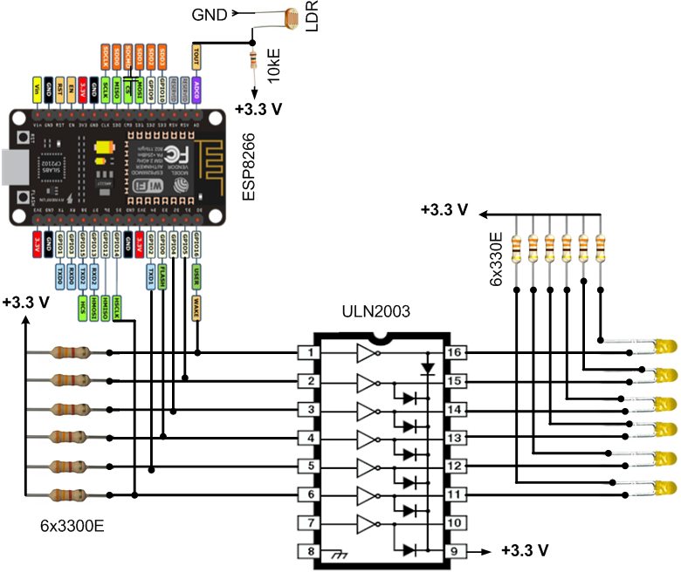

**Fig. 3.1:** Circuit Diagram of Light Sensing Module

## **3.2 Functional Requirements**

1. **Diverse Connectivity:** IoT device should be able to connect to diverse number of devices preferably using Ethernet. Should also be able to connect to other devices using Bluetooth also when required.
2. **Heterogeneous devices:** As IoT device has to access data about the conditions such as light intensity it should be able to manage heterogenous set of devices.
3. **Handle massive amount of data:** As data will be collected from various sensors and will be analyzed therefore device should be able to handle massive amount of data accordingly.
4. **Security:** As data transmission will be done on the basis of web based architecture chances of hacker attacks are always there. So, device should be analyzed to have robust security measures.

## **3.3 Non-Functional Requirements**

1. **Performance:** Performance is one of the main concern of this project as it should be able to perform even in worst condition and at maximum limit of Bluetooth range. Also, as it includes light sensors they should be able to operate in different atmospheric and temperature condition as ideal condition may not persist always.

1. **Usability:** It should be usable in cross platform environment giving accurate results i.e. overall architecture with component description and dependency details.

## **3.4 Logical Database Requirements**

Light patterns are generated in the Google application called Firebase in sync with the lights used in the hardware circuit. Android project like SMART STREET is added to firebase by following a simple procedure by just simple login/register authentication. Firebase provides security, authentication to user data and automatically stores user’s credentials using bcrypt (a password hashing function based on blowfish cipher) so that users can keep their focus on user interface. It supports various features like real time database, authentication, analytics, cloud functions, etc. The application shows the daily, weekly and monthly basis active users in graphical form and text. Any new user is added through authentication tab add user by entering the mail id of that person and password for keeping it secure. Once registered, the system generates user ID of the particular user who has enrolled. Database for the street light pattern is added in the database option and can be modified on real time basis. Name and value is provided for particular lamp. Child i.e. sub-parameters are added to the parameters [45], [46]. The data like latitude and longitude of the university lamp’s exact location is taken from the Google map and the values are saved in the sub-parameter space. Lastly, the number of total lamps is added so that the lamps are shown at exact position in the android application of mobile correctly. Fig 3.2 represents the Firebase application and SMART STREET project added up. The database also stores related parameters like temperature, visibility, intensity and time information. The information is sent from the Wi-Fi module and Weather API via the Android App to the connected Firebase Database and uploaded there. This dataset can then be used for Machine Learning purposes as well.



**Figure 3.2**: Firebase Application

## **3.5 Design Documentation**

### **3.5.1 Use Case**

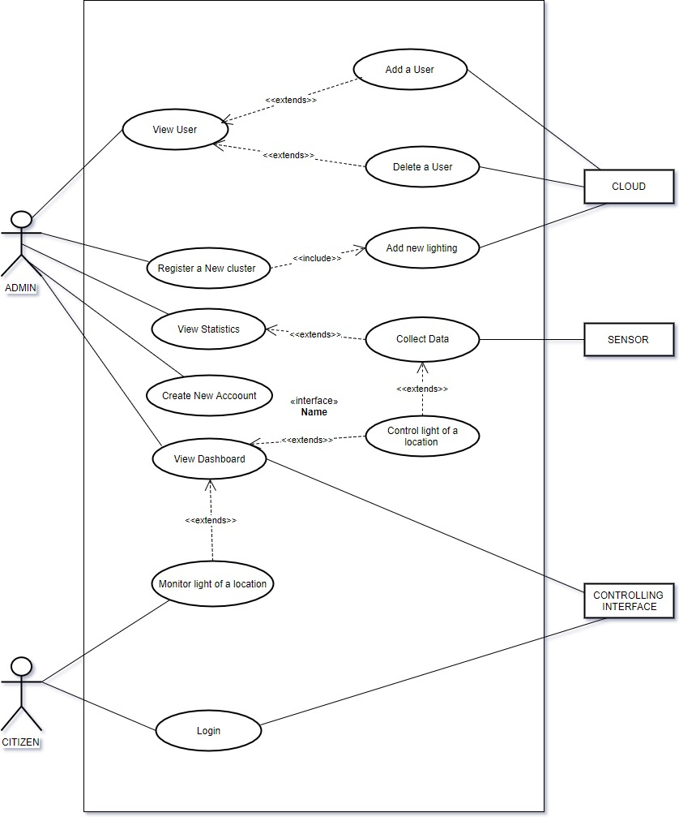

**Fig. 3.3:** Use Case Diagram

### **3.5.2 Flow Diagram**

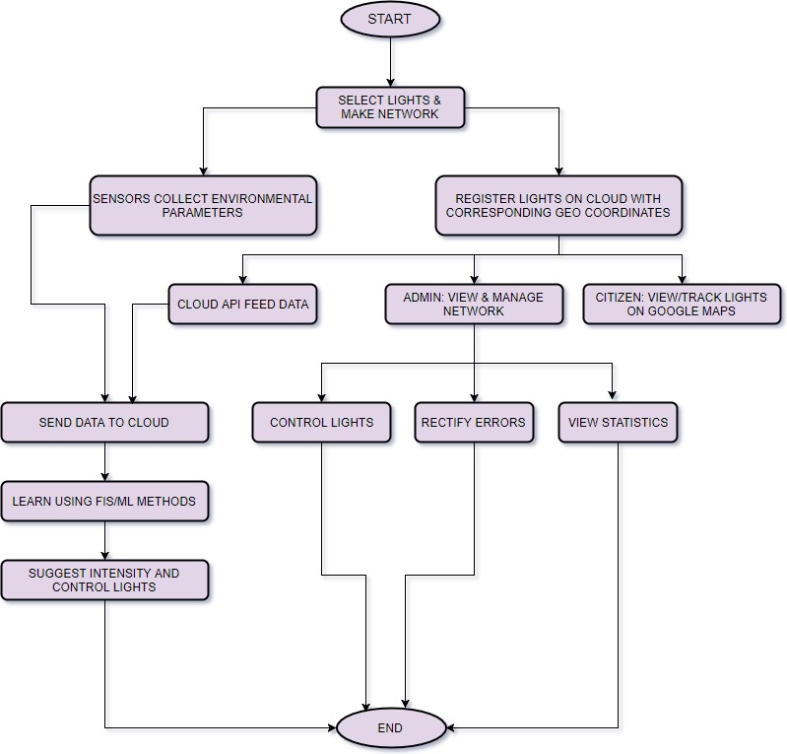

**Fig. 3.4:** Flow Diagram

### **3.5.3 Class Diagram**

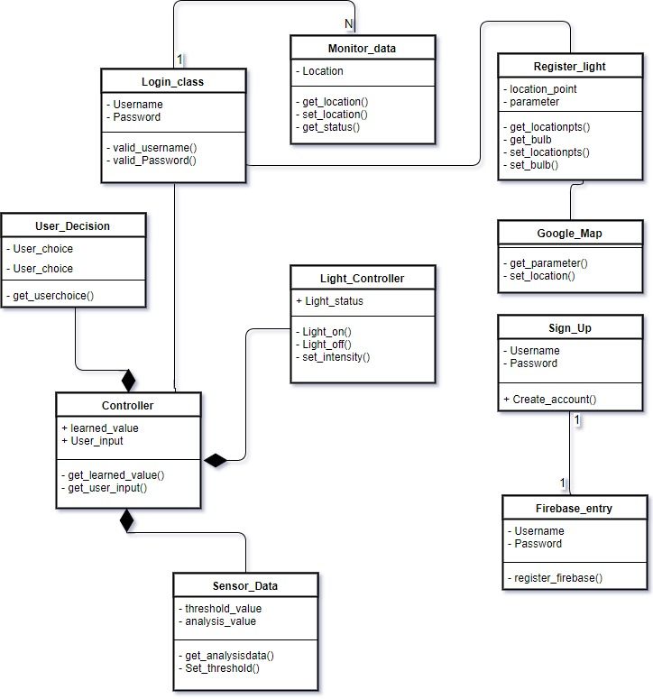

**Fig. 3.5:** Class Diagram

### **3.5.4 Activity Diagram**

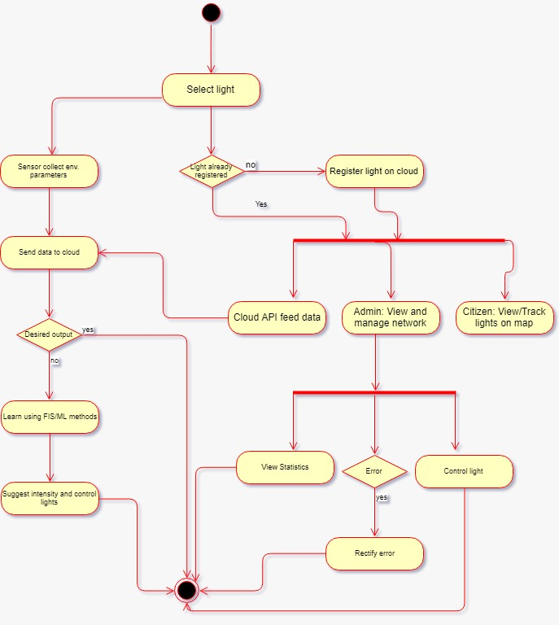

**Fig. 3.6:** Activity Diagram

# CHAPTER 4: IMPLEMENTATION DETAILS AND ISSUES

## **4.1 Implementation Details**

LUA interface is used for programming of lights in ESP8266 chip to control the light pattern of the hardware circuit. NodeMCU firmware implements LUA 5.1 over Espressif SDK for its ESP8266 SoC and the IOT modules based on this. NodeMCU LUA is based on eLUA that is a featured implementation of LUA 5.1 and is best suitable for embedded system development and its execution. NodeMCU LUA provides a scripting framework that is used for useful applications within the limited RAM and flash memory resources of embedded processors like that of ESP8266. NodeMCU dev kit is used to open appropriate COM (communication) port for ESP8266 processor through USB cable and SPIFFS (Serial peripheral interface flash file system) that requires a good Wi-Fi connection. In order to enable ESP8266 firmware flashing, GPIO0 pin must be pulled low before the device is reset. Fig 4.1 shows the communication between the ESP8266 and system [25,5].

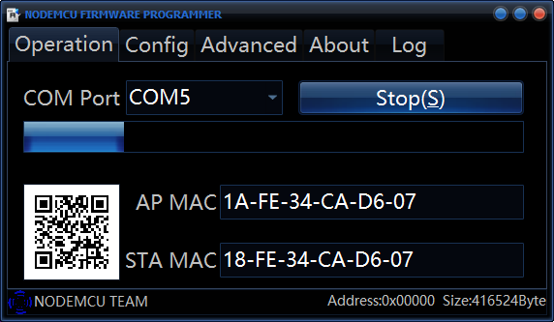

**Fig. 4.1:** Establishing communication between ESP8266 and port

After establishing communication, init.lua script is uploaded in the ESPlorer application. Any modification in the script can be done on the real-time basis. Port is opened up and script is saved and run on the ESPlorer. After the final script is ready, it is saved to ESP8266 and connection is established on a particular IP address. Once the script is saved onto ESP8266 processor, it remains there in the memory and no need to connect USB every time. Fig 4.2 shows the uploading of LUA script.

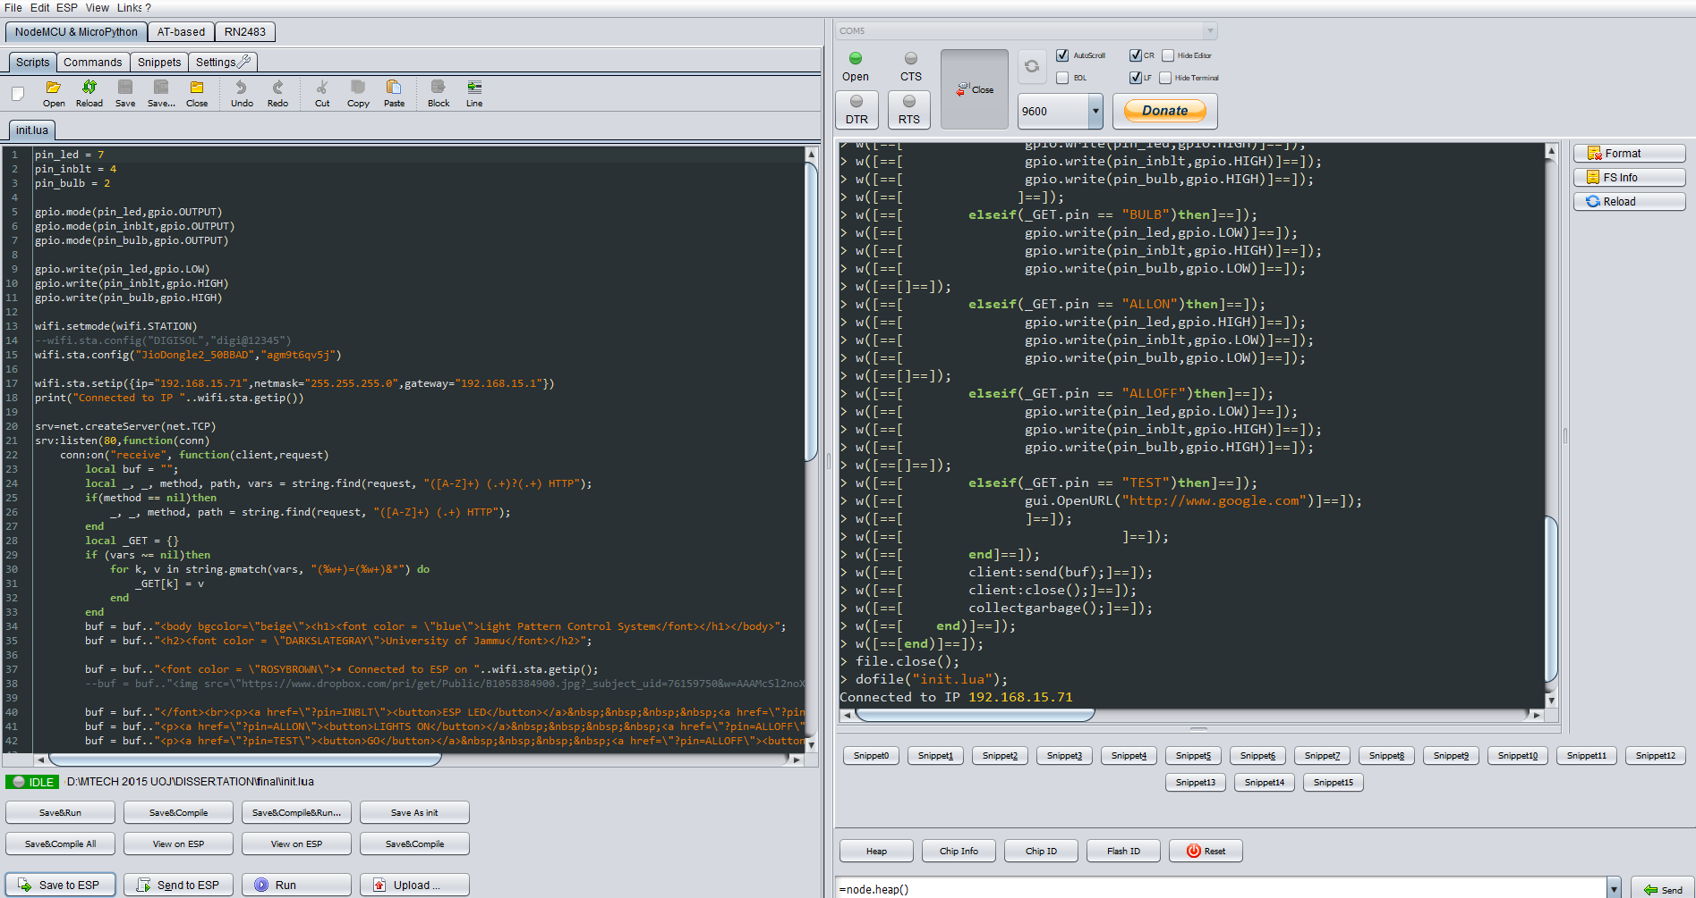

**Fig. 4.2:** Uploading of LUA script in ESPlorer

LUA script can be modified in real time as per the requirement of the project. In this script, three lights i.e. bulb, LED and inbuilt LED are used as output. These lights are assigned to ESP8266 pin numbers 2, 7, and 4. After assigning pins, the lights are set to their default modes as LOW or HIGH and Wi-Fi connection is established by setting IP, net mask, and gateway. Further conditions are set to control the light system. Table 3.1 displays the LUA code snippets.

The main objective of the project was to eliminate the manual efforts to control the lighting system automatically and remotely. First and foremost, step for the fabrication of hardware circuit was to create the list of electronic components and to identify input and output of the system to control the lights. Output is in the form of three lights that are ESP8266 inbuilt LED, outer LED and pole bulb that switches ON or OFF as per the user’s instruction. The design is tested on the prototype model and works accurately. The system can be implemented in real life scenarios. The circuit can be positioned on the pole so that it is controlled remotely using Wi-Fi centralized network, Ethernet or Bluetooth by the authorized operators.

The circuit system can be copied and multiple circuits can be designed to be placed on the poles where the light has to be operated automatically in some particular area. All the systems designed can be differentiated from one another by the unique IP address to which their microprocessors are connected to. The system through microcontroller can be further modified to detect sensors from temperature, humidity, moisture, and water as per the requirement of the system. It can also display the time on real time basis on LCD (liquid crystal display) and can take audio-video input-output. The system can be used for security purposes or emergency.

Two circuits are designed to simultaneously control the lights on different poles through the same microcontroller used in the both circuits. Modifications in the circuits designed can be done as per the requirement.

After circuit is designed, NodeMCU LUA interface is developed and saved to ESP8266 processor. All the lights are assigned to the specific pin numbers of the processor with whom they are connected and are set to output mode. Wi-Fi connection is established by giving the suitable IP details. Buttons format, font and style are programmed in HTML in LUA code itself. Various conditions are set to control the three light systems. This code can be further enhanced by increasing the number of lights and conditions associated to increase the security. Fig. 4.2 represents two hardware modules flashing lights as per the program interface. It displays all the lights of both the circuits ON.

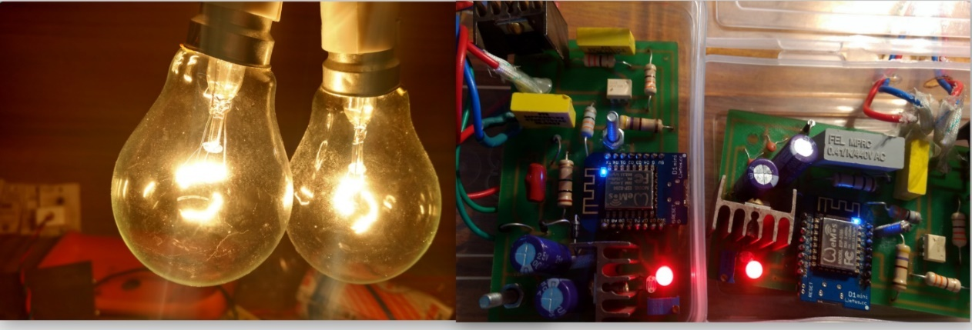

**Fig. 4.3:** Hardware Module for Remote Control Operation

Mobile application is developed in android studio with login and street map activity. Functions like onCreate, onESP, onLogin, onOffline, validateEmail, Firebase authentication, etc. are created to work in modules and develop different patterns. When users open the SMART STREET application on their mobiles, firstly authorized users have to login. A map of university will open up and will display the poles at the location where the circuit is placed, on clicking on one of the lamp, IP address will be displayed and then five options will be displayed as Lights On, Lights Off, ESP LED, LED and Bulb. User can click on any one option and can see the expected result. Fig. 4.4 displays the activities of SMART STREET android application.

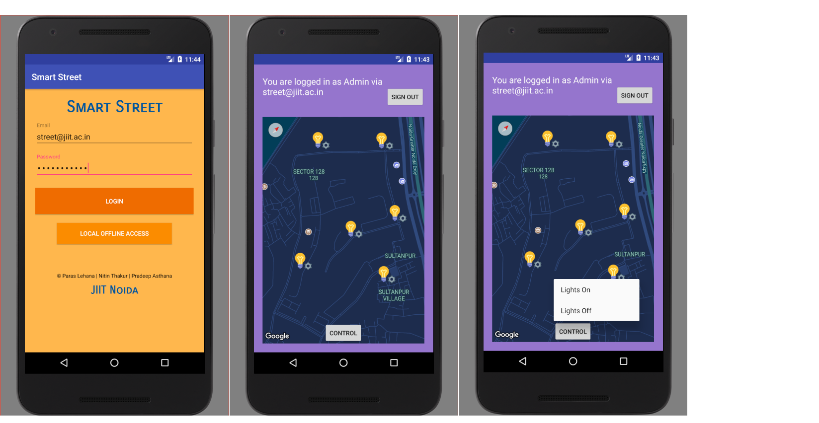

**Fig. 4.4:** SMART STREET App

Firebase application is user- friendly application that adds new user via email and password authentication and also is used to create database containing the pattern for light system. Three parameters signify the light pattern as the name of light, latitude and longitude of the exact location where the lamp has to be placed. The data of the parameters used is taken from Google map. Fig. 4.5 shows the Firebase authentication and database.

Firebase authentication provides security to the authorized users and generates real time data. All the modules together perform as an automatic light system that controls illumination of lights using proposed android based Wi-Fi enabled ESP8266 model from remote PDA device using Firebase database. Any android device can be used to access and control the system remotely, only if the application is installed in the phones of authorized operators.

Fig. 4.6 shows the communication between android device and ESP8266 based circuitry model remotely to control the lights. The android phone that was used for testing the application has android version of 7.0 Nougat OS. This application is compatible with all the android versions. The output automatic light system controls ESP LED (inbuilt), LED, and bulb by the android app through wireless communication.





**Fig. 4.5:** Firebase Authentication and Database



**Fig. 4.6:** Controlling the illumination system using proposed android based Wi-Fi enabled ESP8266 model from remote PDA device using Firebase Database in different states. *Controlling (a) ESP LED (b) LED (c) Bulb (d) All above three components*

## **4.2 Risk Analysis**

**Table 4.1:** Risk Analysis Table

|  |  |  |  |  |  |  |
| --- | --- | --- | --- | --- | --- | --- |
| **Risk ID** | **Description of Risk** | **Probability (P)** | **Impact (I)** | **RE (P*I)** | **Risk selected for Mitigation (Y/N)** | **Contingency plan, if any** |
| 1. | Schedule risk | 0.2 | 5 | 1.0 | Y |  |
| 2. | Budget risk | 0.05 | 1 | 0.05 | N | Very less chances of budget problem. |
| 3. | Operational risk | 0.3 | 5 | 1.5 | Y | If data set is large, then the throughput  and response time decrease significantly. Scheduling can be done. |
| 4. | Technical risk | 0.4 | 8 | 3.2 | Y | Proper feature Selection is key of better accuracy. |
| 5. | Programmatic risk | 0.2 | 4 | 0.8 | N | Packages, Interpreter and Developing Environment should be install properly. |

## **4.3 Mitigation Approaches**

**Table 4.2:** Mitigation Table

**Mitigation Approaches**

* For Interpreter Problem, re-install/re-open it or check for Lua/Esplorer/Python.
* For unwanted output, check the proper working of sensors, range of variables or functions.
* Copy the Source code and dataset for backup.
* Check environment variables for better performances.

## **4.4 Algorithms**

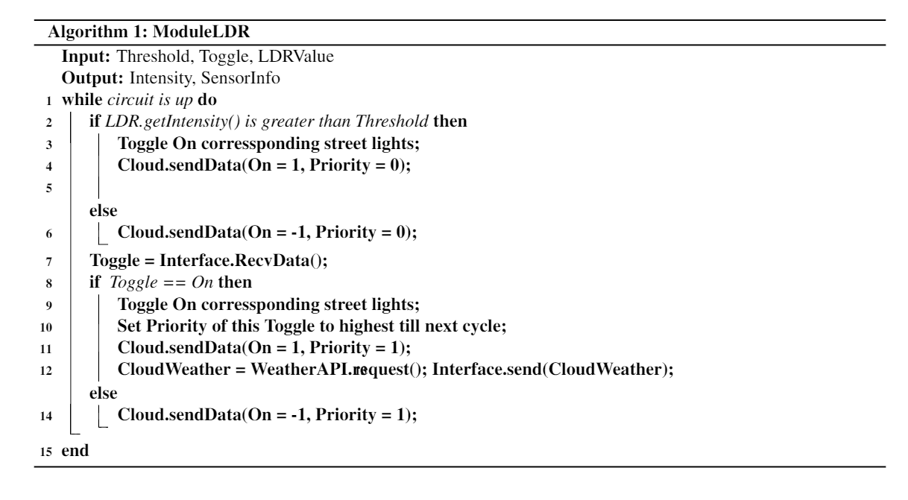

**Fig. 4.7:** ModuleLDR Algorithm

# CHAPTER 5: TESTING

## **5.1 Testing Plan**

**Table 5.1:** Testing Plan

|  |  |  |  |
| --- | --- | --- | --- |
| **Type of Test** | **Will Test Be Performed?** | **Comments/Explanations** | **Software Component** |
| Requirements Testing | Yes | Needed to check if LEDs have correct outputs | LDR module, Weather API |
| Unit Testing | Yes | Every unit needs to checked for correct output | LDR module, Weather API, Master Control, Cloud store and fetch, Login, Maps API, Self-learning |
| Integration Testing | Yes | All modules need to work as expected to produce the combined output | LDR module and ESP8266 output; Master trigger and ESP8266 output; Master trigger and Weather API; Master trigger and Firebase store; Login and Firebase fetch; Login and Maps API |
| Performance | Yes | To determine energy savings and automation status | LDR intensity check; ESP8266 output |
| Stress | Yes | Test for extreme conditions like high voltage and temperature, data transfer. | LDR module; Wi-Fi module; LED module; |
| Compliance | Yes | Wireless communication should be done using standard modules | Wi-Fi module |
| Security | Yes | Intranet and internet communication should follow security standards | Wi-Fi module; Firebase store and fetch |
| Load/Volume | Yes | Test conditions for high intensity and high bandwidth consumption | LDR module; circuit module; Wi-Fi module |

## **5.2 Component decomposition**

**Table 5.2:** Component decomposition

|  |  |  |  |
| --- | --- | --- | --- |
| **S.No.** | **List of Various Components (module) that require testing** | **Type of Testing Required** | **Technique for writing cases** |
| 1. | LDR module | Requirement, Integration, Stress, Unit, Load/Volume | White Box – statement testing, decision testing |
| 2. | Wi-Fi module | Stress, Compliance, Security | Black Box |
| 3. | LED module | Stress | Black Box – cause effect, robustness |
| 4. | ESP8266 output | Integration, Performance | Black Box – cause effect |
| 5. | Master trigger | Integration, Unit | White box – path testing |
| 6. | Login | Unit | White box – path testing |
| 7. | Weather/Maps API | Integration | Black box – cause effect |
| 8. | Firebase | Unit, Integration | White box – path testing, statement testing |

## **5.3 Error and Exception Handling**

**Table 5.3:** Error and Exception Handling

|  |  |  |
| --- | --- | --- |
| **Test Case ID** | **Test case** | **Debugging Technique** |
| LDR/03 | Intensity variation with temperature | Print debugging |
| CLOUD/03 | Lamp data not stored | Print debugging |
| MASTER/03 | Auto Mode ON doesn’t trigger LDR on again | Backtracking |

## **5.4 Test Cases**

**Table 5.4:** Test Cases

|  |  |  |  |
| --- | --- | --- | --- |
| **Test Case ID** | **Input** | **Expected Output** | **Status** |
| LDR/01 | High intensity | Low value (near 0) | Pass |
| LDR/02 | Low intensity | High value (near 100) | Pass |
| LDR/03 | High/low intensity with high temperature | Expected Low/high value | Fail |
| LED/01 | High intensity | Turn off | Pass |
| LED/02 | Low intensity | Turn on | Pass |
| LED/03 | High input on each | Turn on | Pass |
| ESP/04 | High input on A0 | High value | Pass |
| ESP/05 | Unconditional high | Turn all LED on | Pass |
| WIFI/01 | Connect to AP with (SSID, password) | Connected | Pass |
| WIFI/02 | Use Static IP | Connected | Pass |
| CLOUD/01 | New lamp location | Store lamp | Pass |
| CLOUD/02 | Login fetch with internet | Fetch lamps | Pass |
| CLOUD/03 | Login fetch without internet | Remember lamps | Fail |
| MASTER/01 | Click on lamp | IP fetch | Pass |
| MASTER/02 | Auto Mode OFF | LDR off | Pass |
| MASTER/03 | Auto Mode ON | LDR on | Fail |
| MASTER/04 | Lamp controls | Toggle lamp, call weather API, send parameters to cloud | Pass |
| ML/01 | Collected Data | Learning | Pass |

## **5.5 Limitations of the solution**

Machine learning techniques need to selected appropriately that would be able to learn weather changes and areal information patterns. By using LDR only, the output is only dependent on the intensity over the sensor. The sensor can only detect the intensity near its detection radius but not actually the concerned area. This could lead to sensor level detection errors. A third-party weather API is used which is not always reliable. It provides data for only the nearest coordinates up to two decimal points. The Maps API is also granted by Google and restricted to a low traffic usage only. The learning module needs the administrator to operate the Master Control for some initial time in order to make the module learn the outputs. Also, the future outputs are solely dependent upon the learning technique and past data and needs to be calibrated again using master switch.

# CHAPTER 6: FINDINGS & CONCLUSION

## **6.1 Findings**

The ESP module worked with the input threshold levels and toggled the LEDs in as less than as 100-milliseconds testing environment. Wireless commands through the master control interface took less than a minute to communicate while Weather APIs generated local weather data instantly. All the 6 LEDs are connected on a single ESP which still have ample number of pins available for even more of the connections. Thus, costing around INR 500 only, this prototype is economical as well as reliable. The real-time location data is fed by Google Maps API that makes the changes in local geographical conditions to reflect immediately over the interface. As the light bulbs data is hosted on cloud, it is very easy to add new bulbs or edit their locations without changing the source code of the interface applications. The current issues with the LDR could be termed as Machine Errors and needs a human supervisor to guide learning the desired outcomes. For example, a bird sitting on the sensor even in the daylight would cause the module to toggle off the connected LED if there’s no other perimeter to decide this. The outputs from each of the bulbs in the cluster can also help determine the output. Moreover, machine learning methods can make the module learn the outcomes through the environmental perimeters described in the text.

## **6.2 Conclusion**

This project elaborates the design of server hardware circuit based on Wi-Fi based RISC processor and implementation of the LUA interface with mobile application that automatically controls the lighting system remotely. Hardware circuit works in a proper manner, with ESP8266 as the main processor component and LDR sensor to measure the intensity and hence the presence or absence of light. SMART STREET mobile android application works well as expected. Authorized users are able to control the lights easily and efficiently. The system has reduced the manual efforts and has automatized the control, thus saving energy. This automatic control system is useful in many applications for home, offices, institutions or large establishments.

## **6.3 Future Work**

The above project could be developed using solar street light panels along with the automatic street light controller. The system could then supply itself power by harvesting the solar energy through a solar cell during day time through battery and provides a productive way for the operation of hardware circuit and controlling the light system. Automatic lighting system can be used for emergency, fault detections and for security purposes at home, offices or institutions as per requirement. This system can be used to automatically control home appliances, security burglar alarms, etc. It can be used to measure traffic density and can control traffic of the road. The Phase III of the project deals with Data-Mining and Machine Learning techniques implemented over the data collected by the sensors. This would make the local data available for even smallest of the streets and could make the whole of the area autonomous just attaching the module to the existing infrastructure.

# REFERENCES

1. A. R. Al-Ali and M. AL-Rousan, “Java-Based Home Automation System,” IEEE Transactions on Consumer Electronics, Vol. 50, Issue 2, May 2004.
2. Abinaya, B., Gurupriya, S. and Pooja, M., 2017, February. Iot based smart and adaptive lighting in street lights. In Computing and Communications Technologies (ICCCT), 2017 2nd International Conference on (pp. 195-198). IEEE.
3. Alzubaidi, S. and Soori, P.K., 2012, June. Study on energy efficient street lighting system design. In Power Engineering and Optimization Conference (PEDCO) Melaka, Malaysia, 2012 Ieee International (pp. 291-295). IEEE.
4. Amul Shravankumar, “A Survey on Automatic Street Lightning System on Indian Streets Using Arduino”  
   [*https://www.ijirset.com/upload/2017/march/47_6_A%20Survey.pdf*](https://www.ijirset.com/upload/2017/march/47_6_A%20Survey.pdf)
5. Byeongkwan Kang et al., “Iot-based Monitoring System using Tri-level Context Making Model for Smart Home Services,” International Conference on Control, lnstrumentation, 2015 IEEE International Conference on Consumer Electronics (ICCE), 2015.
6. C. Ururahy et al., “A Lua: flexibility for parallel programming”, Computer Languages Systems & Structures, pp. 155-180, 2002.
7. Charles E. Gimarc and Veljko M. Mhtinovic, “RISC Principles, Architecture, and Design,” Computer Science Press Inc., 1989.
8. Denardin, G.W. et al., “Control network for modern street lighting systems,” Industrial Electronics (ISIE), 2011 IEEE International Symposium, pp.1282-1289, June 2011.
9. EESL, “Monitoring and Verification Report - Street Lighting and DELP projects”  
   [*http://www.ujala.gov.in/documents/Final_Monitoring_and_Verificatio_Report_EESL.pdf*](http://www.ujala.gov.in/documents/Final_Monitoring_and_Verificatio_Report_EESL.pdf)
10. EESL Toolkit for Street Light Energy Efficiency  
    [*https://eeslindia.org/writereaddata/EESL%20Toolkit%20final.pdf*](https://eeslindia.org/writereaddata/EESL%20Toolkit%20final.pdf)
11. Energy Savings Potential for Street Lighting in India  
    [*https://ies.lbl.gov/sites/all/files/lbnl6576e.pdf*](https://ies.lbl.gov/sites/all/files/lbnl6576e.pdf)
12. Ilya Galkin, Olegs Tetervenoks, “The Study of Microcontroller based Embedded System for Smart Lighting Applications,” IEEE Proceedings of 6th European Embedded Design in Education and Research, 2014.
13. Interoperability in the Internet of Things - *https://www.computer.org/web/computingnow/archive/interoperability-in-the-internet-of-things-december-2016-introduction*
14. Iromini, N.A., Nafiu, A.S. and Ajao, A.O., 2015. Automated light control system for offices. International Journal of Engineering Sciences & Emerging Technologies, 7(04).
15. K.Sampath et al., “Intelligent LED Lighting System for Energy Efficiency,” International Journal of Science and Research (IJSR) Vol. 3, Issue 10, Oct. 2014.
16. K.Santha Sheela and S.Padmadevi, “Survey on Street Lighting System Based on Vehicle Movements” by

[*http://www.rroij.com/open-access/survey-on-street-lighting-system-based-onvehicle-movements-.php?aid=46317*](http://www.rroij.com/open-access/survey-on-street-lighting-system-based-onvehicle-movements-.php?aid=46317)

1. Kodali, R.K. and Mandal, S., 2016, December. IoT based weather station. In Control, Instrumentation, Communication and Computational Technologies (ICCICCT), 2016 International Conference on (pp. 680-683). IEEE.
2. Kumar Mandula et al., “Mobile based Home Automation using Internet of Things (IoT),” International Conference on Control, lnstrumentation, Communication and Computational Technologies (lCCICCT), 2015.
3. Lee, H.R., Lin, C.H. and Kim, W.J., 2016, October. Development of an IoT-based visitor detection system. In SoC Design Conference (ISOCC), 2016 International (pp. 281-282). IEEE.
4. Mamun B, Shabiul I. and Sulaiman S, “A Single Clock Cycle MIPS RISC Processor Design using VHDL,” IEEE ICSE2002 Proc., pp. 199-203, 2002.
5. Marktscheffel, T., Gottschlich, W., Popp, W., Werli, P., Fink, S.D., Bilzhause, A. and de Meer, H., 2016, June. QR code based mutual authentication protocol for Internet of Things. In World of Wireless, Mobile and Multimedia Networks (WoWMoM), 2016 IEEE 17th International Symposium on A (pp. 1-6). IEEE.
6. Mohamed Abd El-Latif Mowad et al., “Smart Home Automated Control System Using Android Application and Microcontroller,” International Journal of Scientific & Engineering Research, Vol. 5, Issue 5, May 2014.
7. Pandya, B., Mehta, M. and Jain, N., 2016. Android Based Home Automation System Using Bluetooth & Voice Command. International Research Journal of Engineering and Technology (IRJET) Volume, 3.
8. Pavithra, D. and Balakrishnan, R., 2015, April. IoT based monitoring and control system for home automation. In Communication Technologies (GCCT), 2015 Global Conference on (pp. 169-173). IEEE.
9. Pingle, Y., Ogale, T., Signh, N.C., Sandimani, S. and Shirsath, V., 2016, March. Human detection by measuring its distance based on IOT. In Computing for Sustainable Global Development (INDIACom), 2016 3rd International Conference on (pp. 1434-1435). IEEE.
10. Priyanka Jagtap and Pravin Matte, “A Survey Paper on Street Light Controlling for Energy Efficiency” by   
    [*http://www.academicscience.co.in/admin/resources/project/paper/f201605251464193225.pdf*](http://www.academicscience.co.in/admin/resources/project/paper/f201605251464193225.pdf)
11. Public-key cryptography - *https://en.wikipedia.org/wiki/Public-key_cryptography*
12. QR Code - *https://en.wikipedia.org/wiki/QR_code*
13. R. Piyare et al., “Bluetooth based Home Automation System using Cell Phone,” Consumer Electronics (ISCE), 2011 IEEE 15th International Symposium Singapore, June 2011.
14. Raspbian - *https://en.wikipedia.org/wiki/Raspbian*
15. Roberto Beauclair, “Lua Programming Language,” 2011 [Online] Available: http://www.mathrice.org/IMG/pdf_Lua_Mathrice.pdf
16. S. Matta and S. M. Mahmud, “An intelligent light control system for power saving,” in Proceedings of the Annual Conference of the IEEE Industrial Electronics Society, pp. 3316-3321, 2010.
17. Sayali Arkade, Akshada Mohite, Shraddha Joshi, Rutuja Sonawane, Vikas Patil, , , ."IoT Based Street Lights For Smart City", Volume 4, Issue XII, International Journal for Research in Applied Science and Engineering Technology (IJRASET) Page No: , ISSN : 2321-9653, www.ijraset.com
18. Stergiou, C., Psannis, K.E., Plageras, A.P., Kokkonis, G. and Ishibashi, Y., 2017, June. Architecture for security monitoring in IoT environments. In Industrial Electronics (ISIE), 2017 IEEE 26th International Symposium on (pp. 1382-1385). IEEE.
19. Takeshi Yashiro et al., “An Internet of Things (IoT) Architecture for Embedded Appliances,” YRP Ubiquitous Networking, Japan, Aug. 26-29, 2013
20. W. Yue, S. Changhong, Z. Xianghong, and Y. Wei, “Design of new intelligent street light control system,” in Proc. IEEE Int. Conf. Contr. Autom., pp.1423–1427, 2010.
21. Zanella, A., Bui, N., Castellani, A., Vangelista, L. and Zorzi, M., 2014. Internet of things for smart cities. IEEE Internet of Things journal, 1(1), pp.22-32.
22. Zigbee - *https://en.wikipedia.org/wiki/Zigbee*